**Chapter 62 - UPDATE ON FAMILY – 2013 to present**

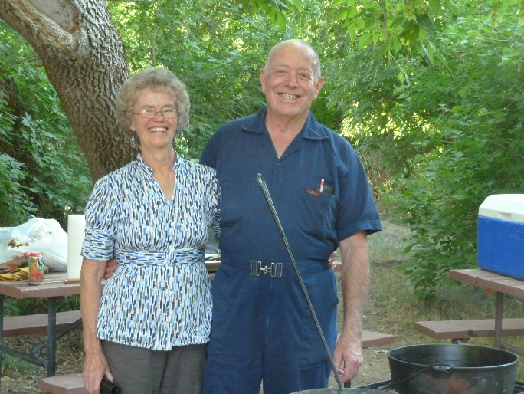**KEN:** I am so blessed to have Ken as my husband, companion, best friend & Sweetheart.

**Here are some of the things he does for me to make me happy**

.

* He has always been very courteous by opening doors for me, helping me on with my coat, pulling out the chair for me at meal time and at restaurants, etc.
* When we go shopping together, he always insists on carrying in the groceries or whatever we have. If there is too much for him to carry in one trip he might let me carry a little, but not much. When we go camping I pack the food, clothes, etc., from the house and he gets the camping gear, fishing gear, etc., ready and then he packs it in the car or truck and when we return home, he carries it all into the house (at least what goes in the house) and I unpack it. **We work together as a team. We do this in most things.**
* When he calls me on the phone he always greets me by saying “Hi doll”, or “Hi good looking” or “Hi beautiful”, Kitten, Love, Sweetheart, Hon, etc. And when I call him, he greets me the same way. He always acts excited to talk to me.
* When he has to get up early in the morning to take a bus route, do handyman work at someone’s house, etc. if I haven’t slept well that night, he has me sleep in and he gets his own breakfast. Always if he is leaving early to go fishing, I fix his lunch the night before and he has me sleep in and he gets his own breakfast.
* Whenever he does leave early in the mornings and I haven’t gotten up, there’s a cute note for me where he tells me to have a good day and expresses his love for me. I love those notes and have kept many of them.
* He loves to show me affection by hugging, kissing and holding hands. I love that too.
* When he has time, which he has never had a lot of time on his hands, he helps me with the dishes or does them himself
* He lifts heavy things for me, feeds the animals each morning unless for some reason he can’t and then I do it. He helps me in many ways
* Elder LaGrande Richards, an apostle at that time and my dad’s second cousin, gave us good advice when he performed our marriage ceremony for us in the Salt Lake Temple, which we have tried to follow. He told us we should have a Friday night date each week even if it was just to go for a walk or go get an ice cream cone. He said we should get away by ourselves, without the children, at least once or twice a year, and at least for a night or two. He said by doing these things we would keep our love alive and grow closer together. We are thankful for this advice as it has done this for us.
* He compliments me on the way I look. He is always saying “You’re beautiful!” even when I don’t think so. He praises me for the things I do.
* When I have callings or presentations to give, many times he helps me or gives me good ideas. He did this for me when I worked at the school district office also.
* Sometimes he surprises me with flowers, or other small gifts. He always brought me flowers when each of our children were born, and many times for our anniversaries, etc.
* He likes to take me shopping on my birthday or anniversary or Christmas sales and if he sees more than one dress, pants, blouse or outfit that both of us like, he wants to buy them all for me. We can’t afford that, but sometimes he has bought me at least 3 articles of clothing

**SANDI: Our oldest child and beautiful daughter**

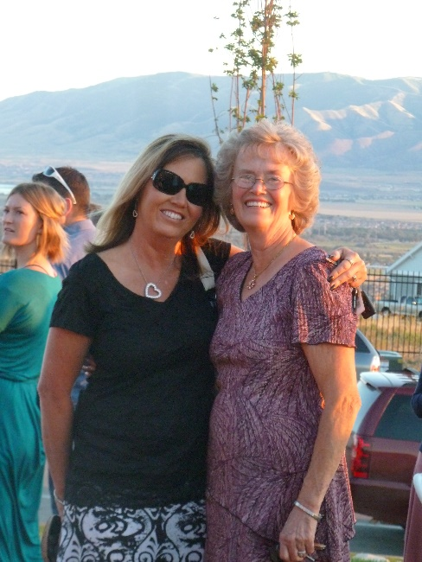Sandi is still working at Grantsville High as their registrar. The beginning and ending of each year are the hardest and busiest times for her. She hopes to retire in about four years. She is married to Nick Drake and they have a beautiful home in Tooele. It is up on Bench View Drive, so she has a beautiful view from their home.

Sandi is always so thoughtful and kind to us, her family, neighbors, friends, etc. Sandi is active in the church at this time. She was a counselor in Young Women’s, and now is the chorister in primary. Nick occasionally comes to Sacrament Meeting with her, but doesn’t stay for the other meetings. He really isn’t interested in becoming active. We are somewhat disappointed in him as he doesn’t do much to help Sandi with the home or yard. He just mainly wants to watch sports on TV. Ken & I have enjoyed going fishing with him & Sandi, especially at Fish Lake, and we have enjoyed going to Country Creek Lodge in the mountains above Soda Springs, Idaho to go snowmobiling on those beautiful hills. We stay a night or two, usually for Ken’s birthday and Sherrie fixed wonderful meals for us and we love playing games at night. Nick does like to play games, so we get together occasionally for dinner and then play games afterward. Nick & Ken stand Sandi & I. Marbles is one of our favorite games we play with them. Sandi has two daughters, JaNae and Chelci, and they are both married.

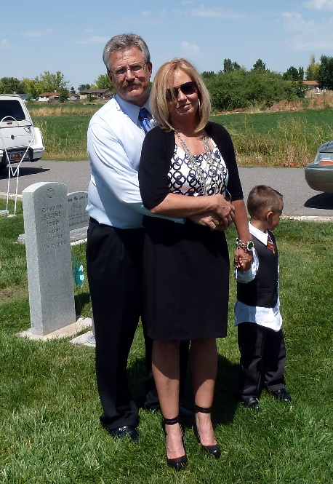Sandi divorced Nick Drake as he was lazy and not fun to be with. He didn’t help her with housework or yard work; she had to do it all herself. He wouldn’t go walking, biking, or any of the fun things she wanted to do. All he wanted to do was watch sports on television. When she married him, he was a sports editor at the Tooele Newspaper and he played sports and refereed them. I guess she should have known that his life revolved around sports. Shellie, Mike & Jeff tried to talk her out of marrying Nick. Her siblings knew that he was lazy and was all about sports. They also knew that he didn’t have any money, so they wondered why she was going to marry him. She told me later that she was tired of dating and it was hard for her to be alone and to go to family, church and other activities alone. She thought he would be good, and she was tired of dating. After she married Nick, he didn’t even show affection to her. On their wedding night, he went to buy groceries for a stop & shop kind of store that he had been doing this for. When they went on a few trips, she said he just complained and made it miserable for her. Finally, she decided she couldn’t take it any longer and wanted to do fun things and enjoy her life while she was young enough to do so.

Sandi had known **Gary Martinson** because they both were involved with the Classified Association from their schools. After her divorce and Gary was already divorced, they started dating. Since Sandi had felt that the men she had married, in the past, changed after she married them, she didn’t want to marry again, especially to have to go through hard divorces. Nick’s was the hardest as he wanted at least half of everything and was not nice about it. Sandi and Gary decided to just “live together”. She had told me before she divorced Nick, that she probably wouldn’t be active in the church if she divorced him. She said she hoped I would still love her, and of course, I said I certainly would as she was my daughter and I loved her very much and I want her to be happy. They lived together for about three years and he did make her happy. He bought her flowers about every week, or at least when they were about gone, he would bring her another bouquet. They love to do the same things, fishing, biking, camping, going on trips, etc. For her birthdays, he doesn’t just get her presents on her birthday, but he makes a week of it. He gives her gifts every day for a week, and he makes her birthday very special. He is always telling her he loves her and how beautiful she is. Her first husband, Dave, was always putting her down, but Gary always builds her up. Gary mainly does the yard work and helps her clean inside the home, helps with meals or whatever Sandi is doing. He is great! Gary has some property, up past Strawberry Reservoir, by the Pinnacle Peaks. He has a mobile home on it and beautiful yard with bear figures all over inside the home and all over the yard. He is a perfectionist and so has a beautiful place. Gary and Sandi love to go there. They have good friends there also.

Gary wanted to marry Sandi and she realized that he is such a good man and shows her lots of affection, and she is sure he won’t change when they marry. He told her that she makes him so happy and he wants to spend the rest of his life with her. They had a condo in Las Vegas for the week after Christmas, 2018. They decided to get married while they were there. They had an Elvis (Impersonator) Wedding. Sandi’s daughter, Chelci, wanted to be at her mom’s wedding, but Sandi told her that they would have an engagement party in the summer and invite family, neighbors and friends to it, which they did and held it in their back yard. It was great! She told Chelci that since this was her 4th wedding, that her and Gary just wanted it to be private. However, it turned out that Gary’s parents and two sets of friends found out and went to it, and they kind of spoiled Sandi and Gary’s honeymoon with being there as the friends stayed the entire week and didn’t want to go and do the same things that Gary & Sandi wanted to do, so Gary & Sandi gave in and went with them.

Sandi is really happy with her new husband. When she told Chelci they were thinking of marrying and asked what Chelci thought, she said: “Great, now my kids can call him Grandpa”. We were happy also and we could now have another a son-in-law.

**SHELLIE: IS OUR SECOND CHILD AND BEAUTIFUL DAUGHTER**

SHELLIE: I am here in Arizona with Shellie, Roy and their family.  I flew down on Friday and will be going home on this coming Friday, the 20th.  My grandson, **Quint**, their 2nd oldest, was going into the military and since I hadn't seen him for quite a while as we hadn't been down for a year, and when Shellie came up, Quint and Kevis didn't come, the last couple of times, as they had jobs here.  Shellie said this would be a great time for me to come.  Ken couldn't come because he is driving a school bus route so he told me to fly down.  I had only planned to be here a week, but Shellie & Roy asked if I could stay an extra week so that they could go on a week vacation to San Diego (where they were planning to take Quint) as their youngest son, Jase, has Asperger’s and is on a special health diet, even stricter than the one Ken and I are on, so they wanted me to be here with the boys so Jase could get the food he needs.  It turned out that Quint didn't go into the military.  He had a leg injury from skiing and as he met with the Marines to work out before going into basic training, it started bothering him.  Since the military has been cut back so much, they really didn't need him, and didn't want him if he couldn't do what he would need to do in the Marines, so they let him out.  When Shellie told me, I thought maybe I should try to change my flight to our Christmas vacation so Ken could come with me, but it cost way too much to change it, so I came anyway, and I'm glad I did.  **Shellie & Roy left on Saturday and met up with Sandi & Nick in San Diego**.  I'm glad the two sisters and their husbands could have this time together.  They were able to get a condo with two bedrooms.  I didn't spend a lot of time with my grandsons the first week, as I knew I would be able to this week and the boys were gone to school, work and Karate.  I did more with **Jase,** however.  This week I have had great conversations with Quint.  He is a special grandson.  He didn't stay on his mission and told the mission president that he didn't have a testimony, but he was in Washington DC and had a Tongan companion as his trainer and that didn't work well.  I think he does have a testimony.  He goes to the Young Adult ward each Sunday, and even last Sunday, when his parents were gone, and he had to work from 4 am until 10 am at Target unloading trucks, he still came home and got ready and went to church.  I was surprised, but thrilled.  We had Family Home Evening Monday night and he had a great attitude and all three of the boys participated and we had a great evening.  I gave a lesson on the Holy Ghost and gave some experiences; we sang songs, prayed, played Pictionary with using scriptures stories and had refreshments.  Mine and Jase's was a healthy snack.  I am enjoying this time with these special grandsons.  They say I am spoiling them, but I told them that I don't get the opportunity to do that very often, and besides that's what grandmothers like to do.

  I have enjoyed this time with Shellie, Roy & the boys as I don't get to see them enough. However, Shellie came up three times this past year and that was great!  Roy came up with her & Jase once.  She mainly came up the first time to get Jase and herself into Nancy, our nutritionist, to see if Nancy could help Jase.  Nancy told her to read the "Gut and Psychology Syndrome" Natural treatment for Dyspraxia, Autism, ADD, Dyslexia, A.D.H.D., Depression, Schizophrenia, etc. by Dr. Natasha Campbell-McBride MD, MMedSci(neurology), MMedSci(nutrition).  Shellie bought it and read it and realized she needed to follow this diet even though it is so hard, but she could tell from reading the book, that this would help Jase.  Nancy tested Jase, Shellie & Sandi and found they are all allergic to Gluten, Dairy and Sugar and that processed foods are so bad for us, so not to use any.  Sandi is on our diet, but Shellie opted to do the GAPS diet.  Shellie is great at fixing all this food from scratch and doing exactly what the book says to do.  I thought I would be going to the Health Store to buy the bread and other items I need for my diet, but instead I am eating the foods she is fixing for herself and Jase.  It's different, but some is pretty good.  The book says if they eat this way for two years, they will be over allergies and their guts will be healed.  They will be able to add more foods in gradually.  However, they will still eat healthy and not eat junk food, pop, or much processed foods.  With eating this way, I am feeling good and I'm not hungry between meals like I used to be, even though I don't eat a lot. They have been on this diet for 8 weeks and Shellie has lost weight and looks great.  Her skin is much better.  Nancy had commented that her skin was bad.  She was allergic to wearing any jewelry and now she isn't.  The best thing is that Jase is doing so well.  He was very picky before and I worried that she wouldn't be able to get him to eat healthy, but after explaining to him about what has happened to people because of eating junk food and processed foods and how he will be much healthier and happier if he eats this way for two years, he decided he wanted to do it.  He is great at it and he is doing much better with his Asperger’s.  His teacher called Shellie and told her that where they used to have a tutor for Jase to keep him on task and help him so he wouldn't fail the tests, etc., now they don't have to and that his grades have improved dramatically.  The teacher said "Whatever you are doing, keep it up as it is working."  We are all thrilled about that.  One day at home, I called the family and Jase answered and said **"Grandma, I didn't used to like the meals Mom fixed, but now I look forward to them.  She fixes good healthy food."**

**Now in 2016**, Jase and Shellie are off the Gaps diet. Shellie thought it was really helping Jase and her, but now isn’t so sure. It was a lot of work and expense, so they have gone back to eating the way they used to eat. They still eat pretty healthy, but not so strict as the Gaps diet was. Jase is a sweet boy, but with Asperger’s, they don’t have social skills so the kids at school and in the neighborhood just pretty much ignore him. Jase likes to be by himself and on his computer. Shellie home schooled him during his Junior High School years, but Garrett talked her into getting him registered in High School as he felt it would be better for him. The home-schooling classes on the computer were harder than what they are at the high school, so Jase does well. He got good grades, but he was on his computer doing schoolwork and homework from morning until night. He didn’t even have a break on weekends and holidays, so that was hard on him and his parents. This is much easier for him now and he has time for himself. He loves “Mind Craft” on the computer and other programs. I bet he will do well after he graduates if he gets a job doing these things as he is a whiz on them. When Shellie & Roy go on their trips, Jase wants to stay home. He fixes his meals and keeps the house clean and they can trust him.

**Letter I left for Shellie & Roy**

**Dear Shellie & Roy,** Thanks for this opportunity of being with your special sons.  They are good boys and I have loved spending this time with them.  They all did their chores on Saturday without any complaints.  We had Family Home Evening on Sunday evening.  Jase conducted, Kev had the songs, Jase and Quint said the prayers, I taught a lesson on the Holy Ghost, Quint did the refreshments (root beer floats for he and Kev and the strawberry ice cream for Jase and I.  We played Pictionary with scriptures stories using the white board and markers.  They are really good at it.  I got it a couple of times, but I had to be quick to get them.  They all participated and had great attitudes.  We have had scripture study some nights when I remembered.  They always knew to have Family Prayer and that is great!  I was nervous about driving the truck when I came down here, but thanks, Shellie, for letting me drive it while you were here.  That made it much easier and soon I wasn’t nervous, but I was still really careful and alert as I sure didn’t want anything to happen to Jase or me or the truck.  Jase did his homework right after school without any complaints.  I went over this week’s spelling words with him and he knew all perfectly except for just a couple.  You will notice on top of your mail that there is a paper telling about the book report Jase is to turn in by Oct 15th. I spent a little over $20.00 for more groceries, so here is what is remaining. I have had wonderful conversations with all of them, especially Quint.  He is so easy to talk with.  Quint & Kev have helped me with the apps and updates on my iPad, for which I am very thankful.  I have appreciated the respect and love they have all shown me.  Quint & I watched “The Gladiators”.  It was intense, but I loved the story and moral.  **Kev** had to work so he didn’t watch it with us.  I watched “Kora” with them and liked it.  I also like a lot of their music and enjoy hearing Kev play his guitar and do his karate.   Jase and I took Tasha with us for walks, especially down to pick up your mail and then we walked further.  Jase has loved his airplane and has flown it several times at the park.  I have gone with him some of the time (when it was cooler in the evenings) and Quint went with us one evening and Jase let him fly it.  Jase and I have played some games together and had fun.  He is such a cute boy.   I have kept Jase on his diet, but he is good to eat the foods I have prepared.  He especially liked the hamburgers and spaghetti I fixed for two of the evening meals and sausage and three eggs for breakfast.  I used your Pamela’s gluten free pancake mix and made pancakes for Quint, Kev and myself and toasted the other pancakes for Jase.  Jase doesn’t care for them very much and neither does Kev.  Kev told me thanks for making these pancakes, but Quint says he likes your diet pancakes.  He thinks he is the only one who does. Quint is excited to move into that home and work out his schedule.  He put in applications around to work a second job and it looks like he will probably get one at Kohl’s.   I think he will do well.  He told me he does want to get into college when he gets the money.  Kev is a cute boy also and just needs attention, praise and love.  We all need that.  I think that’s why Kev loves to be with Quint so much is that he knows that Quint loves him and accepts him for who he is.  They know that both of you love them too, but sometimes brothers as well as sisters (like you and Sandi) can be really close and love to be together.  I know Mike and David have always shared a special closeness like you and Sandi do now. Anyway, I have missed Dad, but I told him thanks for being sweet to let me come because I needed this time with this special family, that I don’t get to see often enough. I sure love you, Mom

**Shellie didn’t like their home and neighborhood in Queen Creek, so they were excited to find a home in Chandler and in the Pecos Ranch subdivision where they first had a home. This home is on one of the lakes.** I loved this area before when they lived here, and so I was excited to hear they had bought this home. With all the homes they buy, they remodel a lot, and this home was no different. They made major changes to the inside of the home. Roy is so talented with framing, electrical – about everything, and Shellie is equally talented in finish work, tiling, etc., etc. Their home is beautiful. It is smaller than their other homes with just three bedrooms, but they have a computer room, beautiful kitchen with family/living room. Now (2019) they have spent most of the winter and spring completely redoing their landscape. Dad and I haven’t seen it yet, but from what we’ve heard, we know it is beautiful. Shellie said neighbors and other people would stop by and ask for a tour, while they were working on it. It is June now, and they are finally finished, and they are so happy with it. It is self-containing now, so that will be nice.

Shellie decided that since Garrett is in the military as a dentist and their family is in Colorado and will be transferred to Germany in July 2019, Kevis is a Marine and stationed in Okinawa, Quint is working at Wells Fargo Bank and not living at home, and Jase is 18, drives, will be a senior this coming fall and can take care of himself – fix food, etc., **she had time now and could get a job and go to work.** She was hired as a receptionist at a dental clinic. The dentist, who owns the clinic and also the office manager, who are both female, are not great to work for and with. She has worked there for several months now, and when she gets enough experience, she will quit and find a better place to work. I miss having her home and not working, as she could come to Utah and visit us more often and when we went there to visit, she was home and we could do lots of things together. Oh well, I worked to and so the situation was reversed.

When we would visit Shellie, Roy & family, we enjoyed our time with them, and enjoyed these cute grandsons – Garrett, Quint, Kevis and Jase. Garrett went on a mission to the state of Washington, came home and married a beautiful girl, Nora, in the Mesa Temple. They have three beautiful children: Maggie, Damon and Aubrey Liesel. I will tell more about these grandsons in my “Grandchildren” chapter.

**Shellie** is a wonderful mother and taught her children the gospel – they had Family Home Evenings, Scripture Study, Family prayer and since Roy made good money, they had nice homes, entertainment items, a beautiful and a beautiful pool at their one home and a theater room in their Queen Creek home and have a home on a beautiful lake now. Both Sandi & Shellie are wonderful homemakers, wonderful home decorators and very talented at all they do.

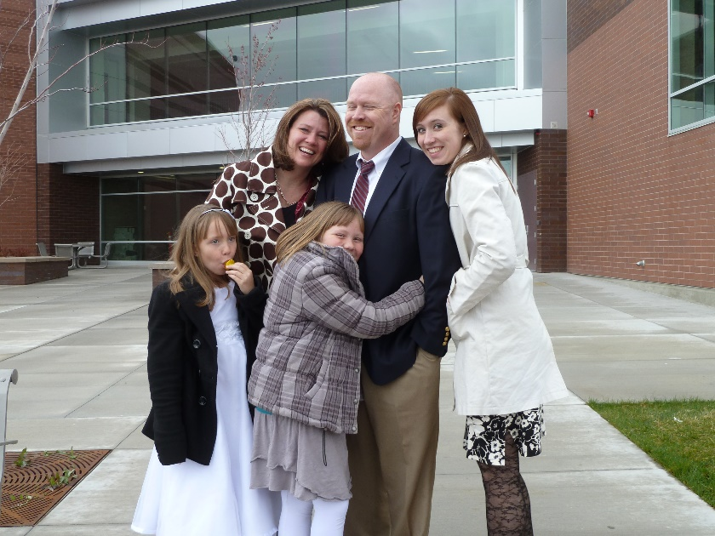 **Mike** went into the Education Field and became a Resource teacher in Montana, but Becky wanted more than two children and Mike knew that he would need to make more money to support a larger family, so he and Becky decided that he should go back to BYU and get his Master’s Degree. He is a smart guy so was able to get into a fast, hard Master’s program which he would complete in one year instead of two. It was hard, but he did it. They have had two more daughters, Maddi and Jessie. Jessie was born while we were on our mission to the Philippines. In fact, she was born about two weeks after we left. Mike got a job as an assistant principle at a junior high school. Later he was a principal at a new junior high which had about 3000 students. That was hard. The next year they changed boundaries and the student population went down considerably so this was a much easier year for Mike, besides he knew the staff and teachers and it was his second year there. The superintendency wanted him to come to the district as one of their resource directors as he knew the law so well. He told them he would for one year, but then he wanted to go back to a school. He did, and the following year was given a assistant principalship at another junior high school**. He is now the principal of Orem High.** It is a beautiful school and he is a great principal. He loves the students, yet they know if they don’t obey the rules he can give out discipline too, so they like and respect him. He supports them in all their games and activities. He is really busy, and it is stressful too especially as the world is becoming more wicked. There have been shootings in schools, so Mike took training and has a permit to carry a gun. He says he would use it too if he had to, to protect his students and teachers. I worry about him because of the stress, he could have a heart attack. He had told me before that he didn’t think he would live beyond 40 years old. He will be 44 on the 28th of this month (April 2013.), so thank goodness, he has lived beyond that. I hope he can live to see his grandchildren**.**

**MIKE: 2018**

Mike has always been into technology. He has always bought and used the latest and greatest technology, whether it was a computer, phone, camera or whatever. I always wondered why he seemed to need this, but I found out this year when he was interviewed by the press and was on the news on TV. Mike was the principle of Orem High and this was his seventh year. He has always been concerned about the safety of his students as there had been multiple high school shootings over the years, throughout the country. He did carry a gun and was certified to use it. But he was worried this might not be enough, so he worked with the district and the police department and he developing a video system, that should a shooter enter his school, he could quickly use this technology to notify the police. They could then immediately view his school and every nook and cranny of it to find the shooter, a squat team would be there immediately, find the shooter and hopefully stop him before he had time to kill or injure any of the students, teachers or staff at the school.

At the end of the school year, Mike was asked to go to the district where he can now help implement this system into the other high schools in their district and then Junior High School and Elementary Schools. Mike is very smart and very capable. Being a High School Principal is hard because there are so many extracurricular activities and he and his assistants need to be there to monitor them. Some of his assistants were not that helpful, especially one, so Mike did more than his share and was gone from home most of the time. I doubt if many High School Principals were as dedicated as Mike and sacrificed their time as much as he did, but Mike felt he had to. Mike loved his students, but besides the time, it was also very stressful. Becky said Orem High owned her husband and she is thankful to have him back again. He is more relaxed and just works 9 to 5 (or 8 to 5, not sure which), so he can enjoy his family more and have an easier life.

Mike would go to conferences, with his work, usually to St. George and he would take Becky with him as often as possible. They would ask me sometimes, if I could come and stay with their children. I loved to do that. Sometimes Ken would come with me. One of the fun things we liked to do with these children, is to take them bowling. Afterwards, we would stay at the grocery store and buy a carton of ice cream to eat when getting back home.

Mike does special things with his children. He has taken David to Las Vegas, a few times, as that is a favorite place for them and they love the buffets with all the good food. He has taken Paige on trips too. He takes Maddie & Jessie out to eat when the other family members are gone. Mike has a nice motorcycle and he rides it to work in good weather. Ken and I borrowed it one time and rode up to Heber City and down Emigration Canyon. It was fall and was so beautiful. I loved sitting behind Ken and feeling the wind on my face and seeing the scenery much better than in a car.

We are proud of Mike. He is a good man, a good husband, father, son and grandfather. Their son, David Michael and his wife, Sierra, have two cute little children – Henry David & Charlotte “Charlie” Mae. I was honored that they choose to give their beautiful little daughter 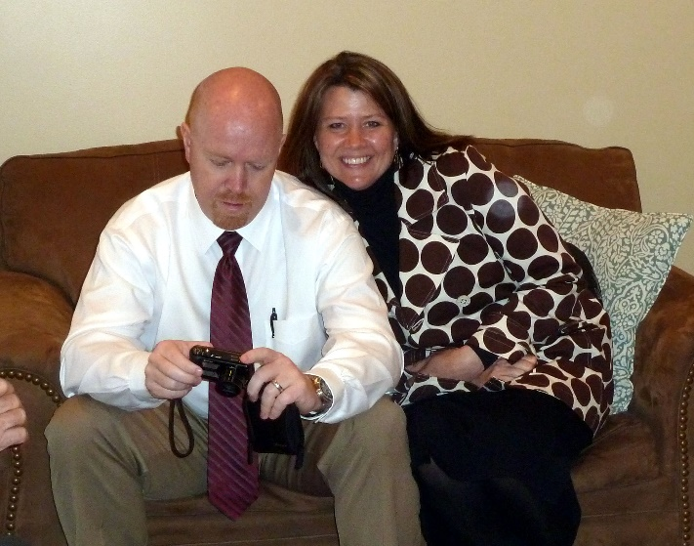my name as her middle name. Their daughter, Paige and husband, Garrett, have a cute little daughter name Wren. These grandchildren sure love their grandparents. Mike is a wonderful grandfather and has such fun with these cute grandchildren. We love Becky. She is a beautiful, wonderful, supportive wife, mother and grandmother. She is one of the best cooks I know and we always love to be invited to their home for dinner or a holiday. We love their family and love to be with them and support them in their talents and activities.

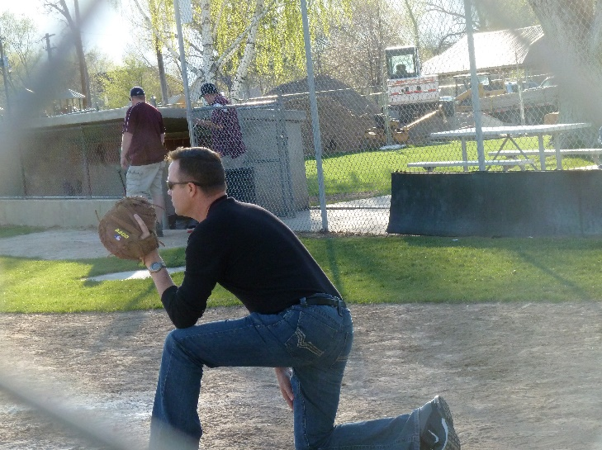 **David** went to Weber State University after returning from his mission to France & Belgium. He knew he needed to get scholarships, so he studied hard. He wanted to go into the medical field to become a physician’s Assistant. He got a part time job working at a lab. He enjoyed the work and it helped pay for his college. I was glad he was living here with us as he would come home and tell us about his experiences and what he had learned. He met Shauna Howard in one of his classes and asked her out. He dated her, and they were married in the Salt Lake Temple in 1994. He got accepted to the PA Program at Pocatello University in Idaho. We went to visit them one time and saw squirrels scurrying all around the campus as there were lots of trees & grass on the campus. A friend told him about a position as a Pharmaceutical Representative which would make him great money and was still in the medical field. Even though David was doing great in the program and the professors and those over his program hated to see him leave, he did join the Pharmaceutical team and they moved to Idaho Falls. They bought a nice home and lived there where **Tyler and Emily** were born. David did make great money as he was their number 1 representative. He won wonderful trips and was able to take Shauna with him. While Ken and I were on our mission to the Philippines, they were missing family so David was able to get transferred here to Utah. **They bought a home in Enterprise, which is close to Morgan.** David continued to be their number 1 representative and made great money & bonuses. Their third child, **Connor**, was born while we were on our mission. In 2011, **David and Shauna made the decision for David to apply to the University of Utah to become a PA.** He didn’t know if he would be accepted as he had already been in the PA program in Pocatello and dropped out and David said that they usually don’t accept people who have been in the Pharmaceutical Industry, but he was accepted. He will graduate with honors this August. He has loved learning in this field and has had the high scores in his classes. **Shauna** graduated as a nurse before their children were born and worked until they moved to Idaho. A great position at McKay Dee Hospital opened up and Shauna applied for it and got it. She had wanted to wait to go back to work until Connor was in school, but this opportunity was now. She was able to work it out that **her mother and I would each tend Connor one day a week** and she was able to put him in the preschool at the hospital for the other days. I enjoyed this time with little Connor. He was so cute, and we had great fun going to the park, playing marbles, and many other games. Parcheesi was his favorite. Sometimes David or Shauna would drop him off here and sometimes I would go there. Shauna insisted on paying me, but that wasn’t necessary as I enjoyed my time with him. David is a great husband, father and son. We love him, his beautiful wife and special children. David will make a great doctor as he has a great personality, cares about people, studies hard, knows what he is doing, and loves helping people. David has a nice motorcycle and so does Mike, so the two of them go on motorcycle trips together. They have gone to Las Vegas together at times too. These two sons have always been close and do a lot together, at least when they have time. David & Shauna invite their families to come stay with them at different times.

We were invited to go to **Paris, France** with David, Shauna and her parents and brother. What a wonderful trip that was. I think this was in the year 2000. Usually, we wouldn’t have the money to go there, but my mom had passed away, we sold their home and each of us children got $20,000. I wanted to pay off our new truck, so we didn’t have a truck payment and they took $17,000, but I still had $3,000. Besides that, David & Shauna were able to get great prices on the air fare ($300, round trip, I believe). Shauna, made all the arrangements and David could still speak the language, since he had gone to France on his mission, so we had a marvelous time. I had always wanted to go to Paris, but never thought I would be able to, so this was a dream come true. I loved going into the castles, the Louvre Museum, Notre Dame Cathedral and the Eiffel Tower. Our motel was so cute and in the middle of the city. We ate at restaurants some, but we also bought French bread, cheese and a yogurt drink that was delicious, plus fruit. I loved the chocolate, banana crepes and especially eating them in the cute French cafes. We rode the metro, walked through a beautiful park, went on a cruise down the river at night.

The morning that we were to leave, Ken and I couldn’t find our airline tickets. We knew we put them in a safe place, but couldn’t find them. The others wanted to go see a special museum and had time to do it, so we told them to go ahead and when we found the tickets, we would catch up to them. We finally found them. We walked through a park, stopped and got our last chocolate, banana crepe, and then met up with David, Shauna, John, Vickie & Jason Howard and went to the airport and had a good flight back home. Wow, such a wonderful vacation and it was great being with these special people.

Several years later, David & Shauna invited Ken and I and her parents, to go on a **road trip to California,** I think this was 2015. That was such a wonderful vacation also. Shauna again made all the arrangements; she is great at that. We went to the beach and had a beautiful home there for a couple of nights. We then went to Yosemite National Park. We stayed at a cute farm house and had a great time. Then to finish the trip, we went to St. George and stayed in Shauna’s Parent’s condo there. While there we went to a play “The Little Mermaid” at the open-air theater, and Emily, with her group of violinists and teacher performed there. The trip was great!

David & Shauna are wonderful parents. They have taught their children the value of work. The children all have chores to do and help with the yard. David & Shauna have taught them many things – the importance of studying hard to get good grades, so they can get scholarships. They have taught them to be kind and courteous to everyone. They have taught them a love for Jesus Christ, however, David and his family don’t have a testimony any longer, so they don’t go to church, don’t pay tithing, and don’t keep the Sabbath Day Holy. We are sad about this, but they are such good people, they love each other, their siblings and families, their parents and other people. We are thankful for that and we love them very much.

Their children, Tyler, Emily & Connor are all straight “A” students. When I have stayed with them, while their parents have gone on trips, the children come home from school, get a snack and start right on their schoolwork. They are great kids. They help out with meals and housework, and Tyler and Emily work part time cleaning Dr. Harris & David’s offices. They have always been in sports – soccer for all three, and baseball, basketball, & track for Tyler.

Their family has a beautiful ski boat. They had one before, but Shellie & Roy were selling their boat, so David & Shauna bought it from them. The family are all very good on the water. They also have a beautiful trailer that they pull with their nice truck, so they go camping and boating, at Pine View Reservoir quite often during the summers, as well as other places.

It is now 2019, and **David is a wonderful doctor.** He was hired by Dr. Hansen at the Northern Dermatology Center in South Ogden. David is a great PA and has almost, or more, patients than Dr. Harris does. Everyone loves him because he loves people and wants to help them, and because he is knowledgeable and keeps on top of everything**.** He and Dr. Hansen get along great. With David’s great personality, he has many patients and they really like him. He is very good at what he does and keeps up on the different new drugs and methods of caring for patients. He also has Pharmaceutical Companies ask him to do presentations on new drugs to groups of doctors around the country. The company pays all expenses and gives him $2,000 for each lecture which usually lasts about an hour. Great money.

Shauna has a great job and it is also great because she can do it at home. She calls patients and explains to them the new medicine they are to take and how to take it. I know there is much more to it than that. Shauna is a very smart and capable woman. She amazes me at all she can do. She is very organized, can delegate to her family and they are good to help her, she is a great cook and homemaker. They have a beautiful home and yard in Enterprise. It has a fantastic view.

Tyler just completed his second year at Weber University and gets straights A’s, Emily just completed her 1st year at UVU in Provo and also got straight A’s. Connor will be a Freshman at Morgan High this fall and he always gets straight A’s too. They are all very smart and very talented and great kids.

David and Shauna invite Ken & I to their home for Christmas Eve. They have been doing this for several years and Ken and I look forward to going there.

**SCOTT:** Ken & I have wonderful, sweet, kind and thoughtful children. Scott is certainly one of them. He would do anything for us and he does whenever he can. All we have to do is mention we are doing some project, or doing something which could require some help, and he asks if we could use his help. He never complains if we ask for his help, and we ask for his help more than from the others as he lives closer to us. He never acts like it is a burden for him, he always acts happy to be able to do it. Scott is so selfless. He sacrifices his time and energy for his family, for us and others. If he has neighbors, family or friends who are moving, he is right there to help them. He has a beautiful wife, **Mishelle**. She is a wonderful wife and mother, but *she has terrible and often migraine headaches*. Scott doesn’t have much vacation time, but when Mishelle has one of these headaches, he takes the day off to help her and be with the children. I have told him to call me when this happens, and sometimes he will, but many times he won’t as he doesn’t want to bother me. Mishelle is very talented with crafts and has made me several beautiful items for our home and she makes me beautiful jewelry. I haven’t bought new jewelry for me for a long time, as Sandi used to buy Jewelry from JaNae, when JaNae was selling “Cookie Lee” jewelry and then Mishelle started making jewelry for me. Mishelle can fix about anything. Scott isn’t a handyman, like his dad, but Mishelle is, and if she doesn’t know how, she either asks Ken or looks it up on “UTube”. Scott & Mishelle are struggling with their testimonies, but take their family to church and Scott teaches Sunday School and Mishelle serves in the Relief Society on the activities committee. Scott & Mishelle have four special children – **Kylan,** who is thirteen, **Ashley**, who is eleven and **the twins, Kaden & Kaitlyn** who are five. They are a cute family

2019 - Scott isn’t active in the church now, and I don’t think Mishelle and the children are either, but I hope so. They are a great family. Scott loves Mishelle and his children and he does a lot for and with them. He would do practically anything for anyone, he is such a good guy. Mishelle is very talented and when I have a question on plants or flowers, I call her. She has a beautiful home and yard. She loves working in her yard

Kylan graduated from High School in 2018, is working at an RC store and working to get his pilot’s license. He wants to become a commercial pilot, and I sure hope he can. He is very talented with music and RC planes, and he loves being in an airplane up in the sky. I love to watch him fly the planes.

Ashley will be a senior this fall. She is a beautiful and sweet girl. She has always been concerned about getting good grades and excelling. I’m sure she will get a scholarship to a university. She has lots of friends, but she has some anxiety, like her mom and Dillingham grandparents. She is teaching herself how to play the piano. On YouTube, they have videos teaching how to play. I have gone on walks with her and taken her to lunch sometimes.

Kaitlyn even suffers more with anxiety, Mishelle says. The twins, Kaden and Kaitlyn are special too. With being twins, they always have someone to play with and do things with, although Kaden loves being on the computer playing Mindcraft or on a phone watching videos. I am excited, however, that he is teaching himself how to play the piano. I’m sure Mishelle helps him also as she plays really well. Kaitlyn is also playing some on the piano Kaitlyn loves watching movies on phones also. I used to buy a Grandparent’s pass to Dinosaur Park and I would take these children three or more times a summer. I would take other grandchildren also. I also like to take the twins to the Layton Park where we feed the ducks and geese, they play on the playground and we walk along the river walk. Then we usually go to McDonalds for lunch or a treat. Kylan and Ashley are good to the twins. Yes, they get out of patience with them at times, especially Kylan, but he takes them places, buys treats for them, etc., and Ashley plays with them. Both Kylan and Ashley have cars now. Kylan has been driving since he was 16. Ashley has been a little nervous about driving, but her parents just got her a cute car. She is excited with it. Their family has two dogs, a Golden Lab, names Cloyie, and a smart, white, curly haired and fluffy little dog, named Sadie. I enjoy petting them and playing with them, but Ken and I don’t want a dog of our own.

Scott & Mishelle have a beautiful travel trailer and they love to take it camping with their family. With having our truck and camper, we have gone camping with them at Payson Lake, Causie Reservoir, Lava Hot Springs and Jackson Lake. We love to invite them to dinner or go to their home for dinners or to play games. We also love to go to Grandparent’s Day with the twins, Choir concerts where Ashley performs with the choirs, and band concerts when Kylan was in Jr High and High School.

.

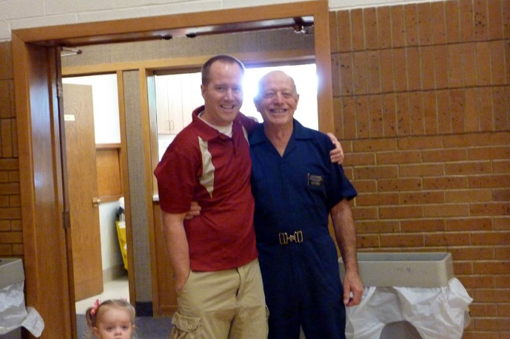**JEFF** & Gail had some problems, so they separated for a few months. Jeff was the controller at the plant in Clearfield. He was able to transfer to the Ohio plant. He rented the upstairs apartment of a home there in Greenville. It was cute as it had a screened in room where Jeff could go and enjoy relaxing. It also had a wrap-around porch with a swing. Jeff had gotten a black lab, from a lady he worked with at the Clearfield plant, and took it with him. He had a small car, so dad helped him pack it. If he hadn’t had the dog, it would have been much less crowded, but we were glad he had it as we were worried about him going off by himself. Jeff & Gail had two children, **Ben and Rachel**, and Gail was expecting their third. She didn’t know she was expecting this baby when they decided to separate, but he (**Matthew “Matt) is our miracle baby** as he brought the two of them back together. They sold their home in South Weber and Gail & her children moved into her widowed mother’s home. During these seven months of separation, they realized they really loved each other and they viewed marriage counseling classes on the internet and discussed them when they talked on the phone. They listed the things they would expect of each other and decided they would make their marriage work. We are proud of them as they have a wonderful marriage now. Jeff came home for a visit and stayed with us for a few days. He invited Gail and the children to come here, and their cute little son, **Ben**, **wouldn’t let Jeff out of his sight**. Jeff was cute to play and wrestle with him, but if he walked into the other room or went to the bathroom, Ben was right behind him. He loved his dad so much and kept saying “**My Dad, My Dad”.** It just broke my heart, as at that time we didn’t know if they would get back together. When Jeff walked Gail and the children out to the car for them to go back home, little Ben kept saying “Come with us, dad, come with us.” Gail told him that dad couldn’t come home with them tonight and he started to cry.

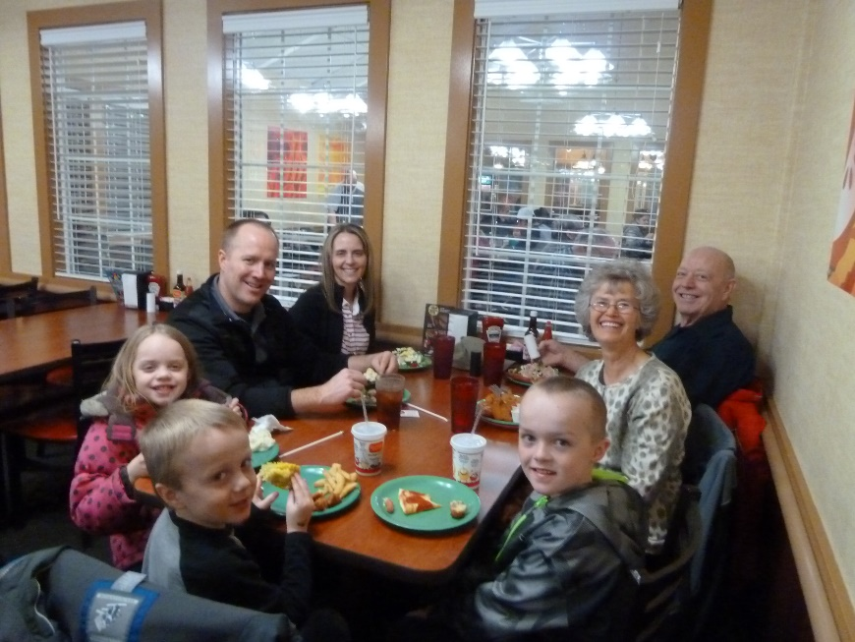I am so thankful that they were able to work things out and get back together – for their sakes and for their sweet children. They bought a beautiful home in Layton up by highway 89. It is perfect for them as they live in a nice neighborhood, but the best thing is that their back yard is part of the hollow. The people, who owned it made a tree house for their children, part-way down into the hollow and they build a fire pit with log benches around it. Further down, they put their trampoline. It was too hard for them to bring up, so they left it there for Jeff and Gail’s family. Jeff needs the outdoors to get away from the world and its stresses, and this is great for him. Their basement has a large family room and a large bedroom with an attached bathroom, but the great part for Jeff, was that the owner of the home had his office, a big room with patio doors leading out into the covered patio, there in the basement. The patio is covered because they have a deck above it which is really nice, and Jeff loves that too, especially as they have such a beautiful view of the hollow with its shrubs, trees, etc., and the mountains on the other side of highway 89. I love to go there and sit out on the deck and enjoy that beauty. Jeff works part of the time from home, so he loves his office.

**Gail** is such a great daughter-in-law; she is so easy to talk with and she is a wonderful wife and mother and the best part is that she does truly loves our son. She was a school teacher when Jeff married her. She taught 2nd grade and she invited me to programs her class put on. Jeff is easy to love as he is so loveable, kind, helpful and patient. He gives me the best hugs of all our children.

One of the great memories I have with this family is going to Zion’s Canyon each summer for several years. It is so beautiful there and we camped together. We had a tent trailer, with a large bed at each end, a bathroom, kitchen with stove and small fridge. They stayed with us. They had a fold up bed for Ben, and it worked out great. That first year, he loved to play in the dirt with his sand toys. We put the vehicles together so he was fenced in, and he had so much fun. They had a stroller and we would take him on the hikes (that had paved walks). We tended him while Jeff & Gail went on the hike to Eagle’s Landing. When Rachel was little, it still worked for all of us to be in our tent trailer. By the time, Matt came along, I think they borrowed Gail’s mom’s tent, however, the two older children could have slept on the table area, which makes into a bed for two children, and Matt could have slept in the fold up crib. When they all got older, they borrowed her tent. Sometimes other family members went with us. Sand with her daughter, Chelci, Steve and their family went once or twice and Nolan came with us a couple of times and slept in our tent trailer. We always had a great time there and went on lots of hikes. As the children grew a little older, they could go on more difficult hikes. Ben loves lizards. He has a net and had fun catching lizards there in Zions. One year, while Nolan was with us, his legs were really bothering him, but he doesn’t let that stop him. I was watching the children while Jeff & Gail climbed Eagle’s Landing again, and Ben wanted me to help him catch lizards. That isn’t my favorite thing to do, but I helped him some. Later, he wanted to do it again, but I didn’t, so Nolan went with him and helped him catch more lizards. Ben got a large lizard for Christmas one year. He loves it and has it in a glass cage in his bedroom. He has had other lizards too. The other children love to play with them too.

The company Jeff was working for, sold the plant he was at. He was a “controller” for them. Jeff could have been transferred to another plant, but they hated to move and leave this beautiful home. However, there were no jobs in the Salt Lake or Ogden area, so he applied for the Financial Manager of Chobani company in Twin Falls, Idaho and got it. They bought a beautiful home with an area of land, which was in grass, shrubs and trees. It was in a nice area. Jeff had gotten an accounting degree, and even though he is very talented in it, he has never liked it. Becky’s dad talked him into that degree as he said, if you have an accounting degree, you can get into whatever field you want. Well, no, he was pretty much stuck in that field. He makes great money, however.

Ken & I love to go up and visit this family and Jeff, Gail and the kids love us to come, so we go as often as we can get away and when they are going to be home. We usually stay for a week. I help with cooking the meals, we play games. Matt especially loves playing games. He will say when I first see him. “Can we play games?” He is a cute little guy. We always have to go to “**Orange Leaf”** which is a frozen yogurt café. It has lots of different flavors and lots of different toppings. Ken can have frozen yogurt, so we all love to go there. We love to go see Shoshone Falls and the Idaho Falls, especially in the spring. We have gone on several mini trips with them, when we go to their home. We always have a good time. They have a guest bedroom with a bathroom next to it, in their large basement, so that’s where we stay.

They invited us to go with them on **a road trip to California with them in 2017.** Jeff rented an RV and he and Ken took turns driving. We ate and played games on the way, and enjoyed the scenery. We stopped at a cave and all but Ken and I went in it. Ken and I didn’t as it had too many steps in it. We enjoyed walking around the area while they were there. We camped at the Red Woods. Ken and I have never been there before and it is amazing. We went on a tour with a forest ranger and he showed us many of the giant redwoods and told us about them. We went to the river, and even though it was pretty cold, Jeff and the kids had fun playing in the river. We went to the place where you can drive through one of the big redwoods. We took pictures there. We went to the ocean and found sea shells, went to a light house where we walked up a trail to it and were able to look around inside it. It’s not in use at this time, but is a tourist attraction. We drove to several places of interest, but it was fun just camping with this special family. Gail wanted to go places and see more things, but Jeff would have liked to just stay at the campsite, relax and enjoy the scenery there. We all had a wonderful time. Things got mixed up when Jeff had rented the RV, so he had to pay more to get one on the dates we needed. He told the family that if we went, since it cost more now, it would have to be their main Christmas present. They all agreed and surely wanted to go. We told Jeff, that it would be our Christmas and birthday presents also, as he had told us that he was paying for us to go with them. We wanted to help with the gas, but he wouldn’t let us, but he did agree that it could be our Christmas and birthday present.

\*\*\*\*\***Find pictures to insert with these**

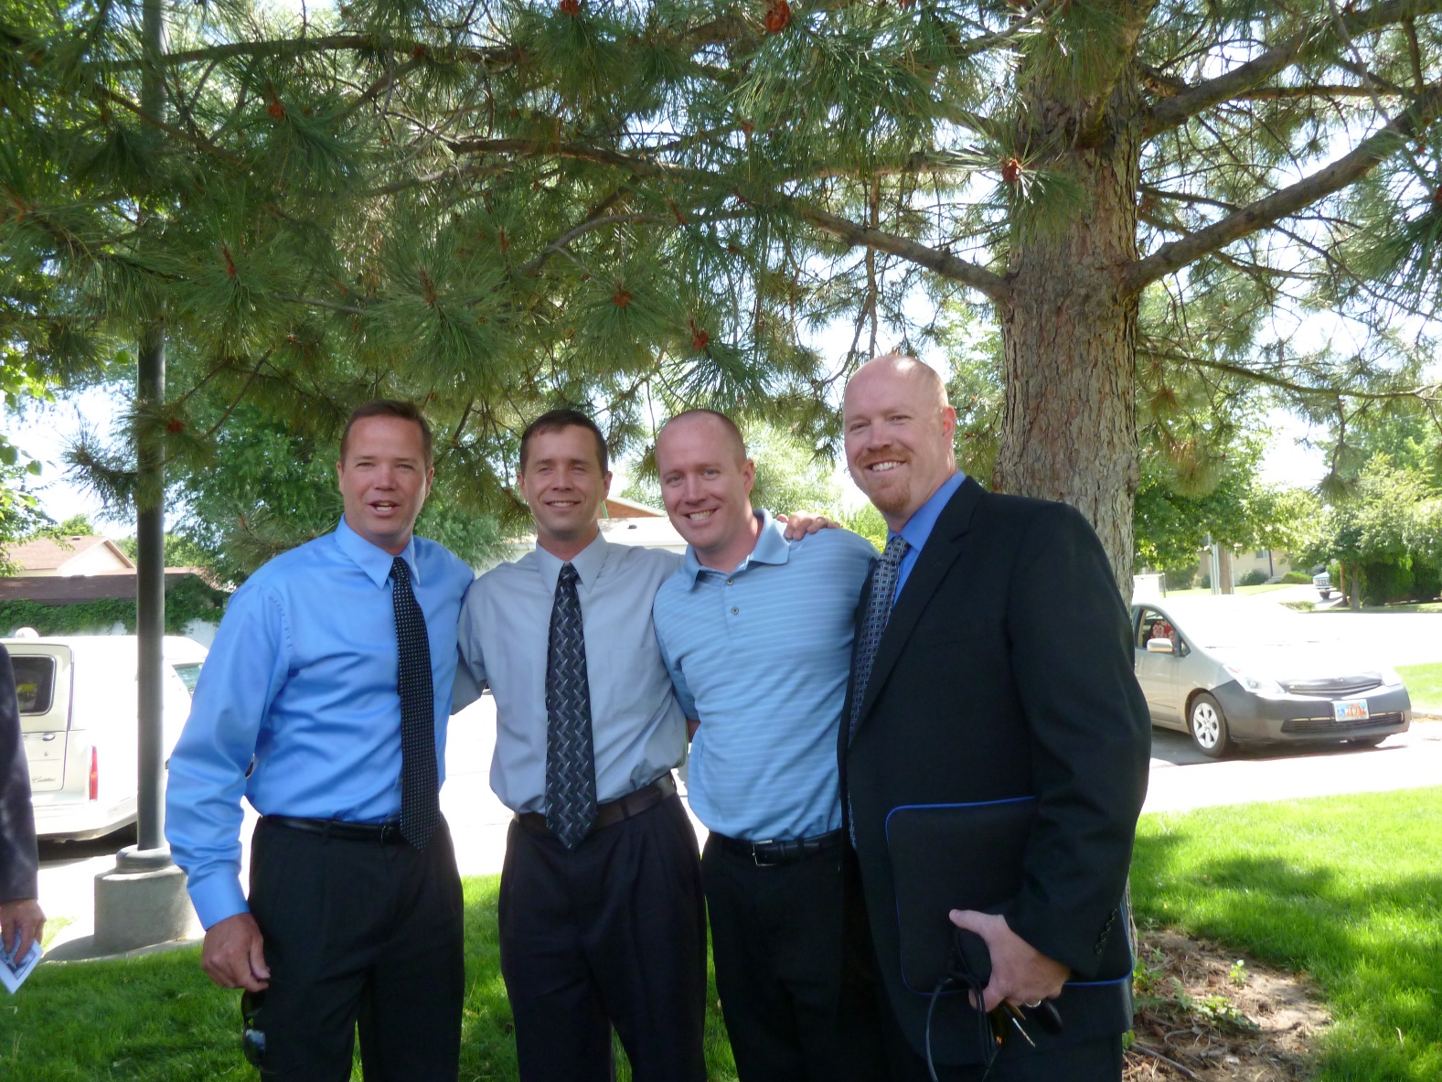

**OUR FOUR HANDSOME, WONDERFUL SONS**



**OUR TWO BEAUTIFUL DAUGHTERS**



**KEN WITH HIS BEAUTIFUL DAUGHTERS**



**Sandi** invited me, and her daughters, JaNae & Chelci, to this special “Time out for Women” conference in Salt Lake. She paid for our tickets and drove us there. That was so special of her. We all had a great time.